

MySQL Assignment

By Enoch Denkyirah



October 23, 2024

There are four parts to this Assignment.

Contents

Task1 – MySQL Part 1: 2

Task 1 2

Task 2 3

Task 3 3

Task 4 4

Task 5 4

Task 6 5

EER Diagram 5

Task 2 – My SQL Part 2: 5

Tasks 6

Task 3 – Interview Questions Part 1: 21

Task 4 – Interview Questions Part 2: 21

# Task1 – MySQL Part 1:

## Task 1

## Task 2

## Task 3

## Task 4

## Task 5

## Task 6

## EER Diagram

The Orders has 3 foreign keys to connect it with 3 tables. The foreign keys are customer_id, order_status_id and shipper_id, linking it to the customers, shippers, and order_statuses tables, respectively. The Order_items table is a bridge to link the orders table and the products table with composite primary keys made up of order_id and product_id, to connect with orders and products.

# Task 2 – My SQL Part 2:

Read from PPT for this task first.

## Tasks

1. **Count Cities in USA:** *Scenario:* You've been tasked with conducting a demographic analysis of cities in the United States. Your first step is to determine the total number of cities within the country to provide a baseline for further analysis.

1. **Life Expectancy & Population in Argentina:** *Scenario:* Find out what the population and average life expectancy for people in Argentina (ARG) is.

1. **Country with Highest Life Expectancy:** *Scenario:* As part of a global health initiative, you've been assigned to identify the country with the highest life expectancy. This information will be crucial for prioritizing healthcare resources and interventions.

1. **"New Year Promotion: Featuring Cities with 'New :** *Scenario:* In anticipation of the upcoming New Year, your travel agency is gearing up for a special promotion featuring cities with names including the word 'New'. You're tasked with swiftly compiling a list of all cities from around the world. This curated selection will be essential in creating promotional materials and enticing travelers with exciting destinations to kick off the New Year in style.

1. **Display Columns with Limit (First 10 Rows):** *Scenario:* You're tasked with providing a brief overview of the most populous cities in the world. To keep the report concise, you're instructed to list only the first 10 cities by population from the database.

1. **Cities with Population Larger than 2,000,000:** *Scenario:* A real estate developer is interested in cities with substantial population sizes for potential investment opportunities. You're tasked with identifying cities from the database with populations exceeding 2 million to focus their research efforts.

1. **Cities Beginning with 'Be' Prefix:** *Scenario:* A travel blogger is planning a series of articles featuring cities with unique names. You're tasked with compiling a list of cities from the database that start with the prefix 'Be' to assist in the blogger's content creation process.

1. **Cities with Population Between 500,000-1,000,000:** *Scenario:* An urban planning committee needs to identify mid-sized cities suitable for infrastructure development projects. You're tasked with identifying cities with populations ranging between 500,000 and 1 million to inform their decision-making process.

1. **Display Cities Sorted by Name in Ascending Order:** *Scenario:* A geography teacher is preparing a lesson on alphabetical order using city names. You're tasked with providing a sorted list of cities from the database in ascending order by name to support the lesson plan.

1. **Most Populated City:** *Scenario:* A real estate investment firm is interested in cities with significant population densities for potential development projects. You're tasked with identifying the most populated city from the database to guide their investment decisions and strategic planning.

1. **City Name Frequency Analysis: Supporting Geography Education** *Scenario*: In a geography class, students are learning about the distribution of city names around the world. The teacher, in preparation for a lesson on city name frequencies, wants to provide students with a list of unique city names sorted alphabetically, along with their respective counts of occurrences in the database. You're tasked with this sorted list to support the geography teacher's lesson.

1. **City with the Lowest Population:** *Scenario:* A census bureau is conducting an analysis of urban population distribution. You're tasked with identifying the city with the lowest population from the database to provide a comprehensive overview of demographic trends.

1. **Country with Largest Population:** *Scenario:* A global economic research institute requires data on countries with the largest populations for a comprehensive analysis. You're tasked with identifying the country with the highest population from the database to provide valuable insights into demographic trends.

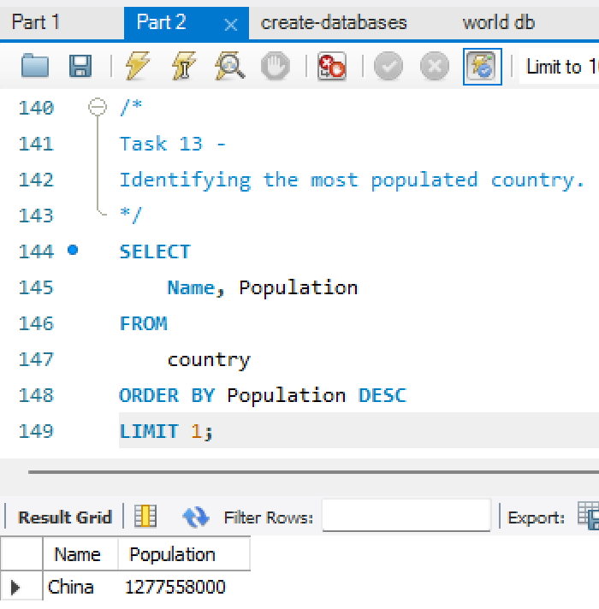

1. **Capital of Spain:** *Scenario:* A travel agency is organizing tours across Europe and needs accurate information on capital cities. You're tasked with identifying the capital of Spain from the database to ensure itinerary accuracy and provide travellers with essential destination information.

1. **Cities in Europe:** *Scenario:* A European cultural exchange program is seeking to connect students with cities across the continent. You're tasked with compiling a list of cities located in Europe from the database to facilitate program planning and student engagement.

1. **Average Population by Country:** *Scenario:* A demographic research team is conducting a comparative analysis of population distributions across countries. You're tasked with calculating the average population for each country from the database to provide valuable insights into global population trends.

1. **Capital Cities Population Comparison:** *Scenario:* A statistical analysis firm is examining population distributions between capital cities worldwide. You're tasked with comparing the populations of capital cities from different countries to identify trends and patterns in urban demographics.

1. **Countries with Low Population Density:** *Scenario:* An agricultural research institute is studying countries with low population densities for potential agricultural development projects. You're tasked with identifying countries with sparse populations from the database to support the institute's research efforts.

BONUS TASKS: Challenge yourself: These are optional tasks. Feel free to skip.

1. **Cities with High GDP per Capita:** *Scenario:* An economic consulting firm is analyzing cities with high GDP per capita for investment opportunities. You're tasked with identifying cities with above-average GDP per capita from the database to assist the firm in identifying potential investment destinations.

Skipping

1. **Display Columns with Limit (Rows 31-40):** *Scenario:* A market research firm requires detailed information on cities beyond the top rankings for a comprehensive analysis. You're tasked with providing data on cities ranked between 31st and 40th by population to ensure a thorough understanding of urban demographics.

1. **Languages Spoken in the Caribbean:** *Scenario:* A market research firm requires detailed information on all the languages that are spoken in the Caribbean. You're tasked with identifying all the languages spoken in this area of the world.

# Task 3 – Interview Questions Part 1:

**What is a query?**

**A command that to access and manipulate data in a database.**

**What is the SELECT statement?**

**A statement in MySQL to** retrieve data from tables in a database.

**What is the WHERE clause?**

The condition used to filter records in table.

**What is the primary key?**

One or more columns that uniquely identifies each row in a table.

**What is a database?**

A structured collection of data that's organized and stored in tables, used for storing, retrieving, updating, and deleting data.

# Task 4 – Interview Questions Part 2:

**List the different types of relationships in SQL and give examples.**​

One-to-Many Relationship:

A row in Table A can be related to multiple rows in Table B, but a row in Table B is related to only one row in Table A.

Example: One customer can have many orders.

One-to-One Relationship:

Each row in Table A is linked to only one row in Table B, and vice versa.

Example: One user account has one profile.

Many-to-Many Relationship:

Rows in Table A can relate to multiple rows in Table B, and rows in Table B can relate to multiple rows in Table A.

Example: Many students can take many courses.

**What is Normalization?**

It is a multi-step process that sets the data into tabular form and removes the duplicated data from the relational tables. Thus it eliminates data redundancy and enhance data integrity in the table. It also helps to organize the data in the database.

**Modify query to show the population of Germany.​**

**SELECT population FROM world**​

**WHERE name = 'France'**​

SELECT

population

FROM

world

WHERE

Name = ‘Germany’;

**​Select the query which gives the name of countries beginning with U.**

SELECT

name

FROM

world

WHERE

name

LIKE 'U%’;

**Select the answer which shows the problem with this SQL code - the intended result should be the continent of France:​**

**SELECT continent FROM world WHERE 'name' = 'France'**

b) 'name' should be name

**Select the code which shows the countries that end in A or L.**

SELECT

name

FROM

world

WHERE

Name

LIKE '%a' OR name LIKE '%l';

**Given the table on the left, select the query which produces this table below.**

SELECT

name, population

FROM

world

WHERE

population

BETWEEN 1000000 AND 1250000;